**Project Design Phase-II**

**Technology Stack (Architecture &Stack)**

|  |  |
| --- | --- |
| Date | 03 October 2022 |
| Team ID | PNT2022TMID45109 |
| Project Name | Project - news tracker application |
| Maximum Marks | 4 Marks |

**Technical Architecture:**

The Deliverable shall include the architectural diagram as below and the information as per the table1 & table 2

**Example: Order processing during pandemics for offline mode**

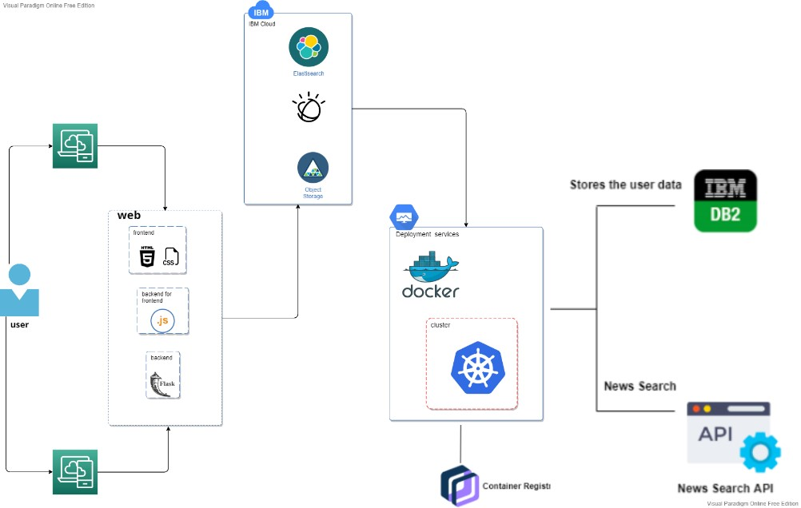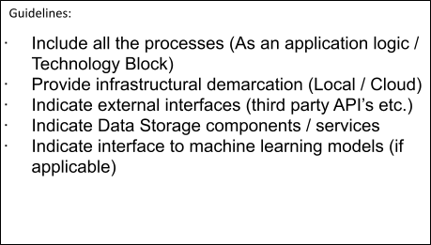

**Table-1 : Components & Technologies:**

|  |  |  |  |
| --- | --- | --- | --- |
| **S.No** | **Component** | **Description** | **Technology** |
| 1. | User Interface | User interact with Web UI, Mobile App, Chatbot etc. | HTML, CSS, JavaScript |
| 2. | Application Logic-1 | create a flask application which connects ibm db2 | Python flask |
| 3. | Application Logic-2 | convert voice into text using IBM Watson STT search in the search engine using elastic search, upload images or files to object storage. | IBM Watson STT service ,object storage,elastic search |
| 4. | Application Logic-3 | Ask queries using watson assistant | IBM Watson Assistant |
| 5. | Database | Data Type and Configurations. | MySQL, NoSQL, etc. |
| 6. | Cloud Database | Database Service on Cloud | IBM DB2, |
| 7. | File Storage | News feeds , video, audio,image | IBM Object Storage |
| 8. | External API-1 | secure ,socialize,manage and monetize, helping power digital transformation on premises and across the cloud. | IBM News API, etc. |
| 9. | Infrastructure (Server / Cloud) | Application Deployment on Local System / Cloud Cloud Server Configuration : SLA | Local, Cloud Foundry, Kubernetes, etc. |

**Table-2: Application Characteristics:**

|  |  |  |  |
| --- | --- | --- | --- |
| **S.No** | **Characteristics** | **Description** | **Technology** |
| 1. | Open-Source Frameworks | A software for which the original source code is made freely available and may be redistributed and modified according to the requirement of the user. | Python |
| 2. | Security Implementations | Cloud Security Posture Management(CSPM),  Detect cloud security and compliance configuration risk, anomalous activity, vulnerabilities, and misconfigurations. | Built-in encryption, BYOK |
| 3. | Scalable Architecture | Python is one of the pioneers of programing languages that developers can use to do all the scaling work. To improve scalability, you can enable or disable services run by the dispatcher on individual servers to balance the load for a given computer by request type. | Technology used in the architecture is that with the Python and the IBM cloud. |
| 4. | Availability | Availability is the ability of a system to withstand or recover from exceptional situations, such as a computer failure. IBM Cloud is on-demand access, via the internet, to computing resources applications, servers (physical servers and virtual servers), data storage, development tools, networking capabilities, and more hosted at a remote data centre managed by a cloud servicesprovider (or CSP). | Technology used are the IBM cloud and the database. |
| 5. | Performance | The updation of trending news occurs without any interruption. So, it performance is good. | Container Registry, Kubernetes Cluster. |